Arrays in Java

The ability to utilize and sort arrays is a critical skill in any programming language. This week’s lesson will use arrays to store information. An algorithm rearranges the data from smallest to largest values.

* Selection Sort
* Insertion Sort
* Bubble Sort

**Assignment:**

Create a single array to store the scores below. The data type of the array should be double.  Then create a sorting class using one of the above methods*. Make sure the sorting class processes double arrays (double[] arrayName;)*. Create a client class to call the sorting Class. Pass the array of scores to the Sorting class. Sort the array from smallest to largest and printout the sorted array.

|  |  |  |  |  |  |  |  |  |  |
| --- | --- | --- | --- | --- | --- | --- | --- | --- | --- |
| **53.5** | **60.3** | **96.2** | **53.3** | **56.4** | **52.7** | **76.4** | **77.5** | **71.0** | **78.2** |
| 65.2 | 59.3 | 80.5 | 92.1 | 85.7 | 78.7 | 66.2 | 88.8 | 50.2 | 73.4 |

**Scores (main class)**

/* Define array and output sorted array from sorter class

Chris Mayfield

*/

package scores;

public class Scores {

public static void main(String[] args) {

// declare, instantiate, and assign array values

double [] dArr = {53.5, 60.3, 96.2, 53.3, 56.4, 52.7, 76.4, 77.5, 71.0,

78.2, 65.2, 59.3, 80.5, 92.1, 85.7, 78.7, 66.2, 88.8, 50.2, 73.4};

// create a new sorter object s1

sorter s1 = new sorter();

// output to console

System.out.println(s1);

}

}

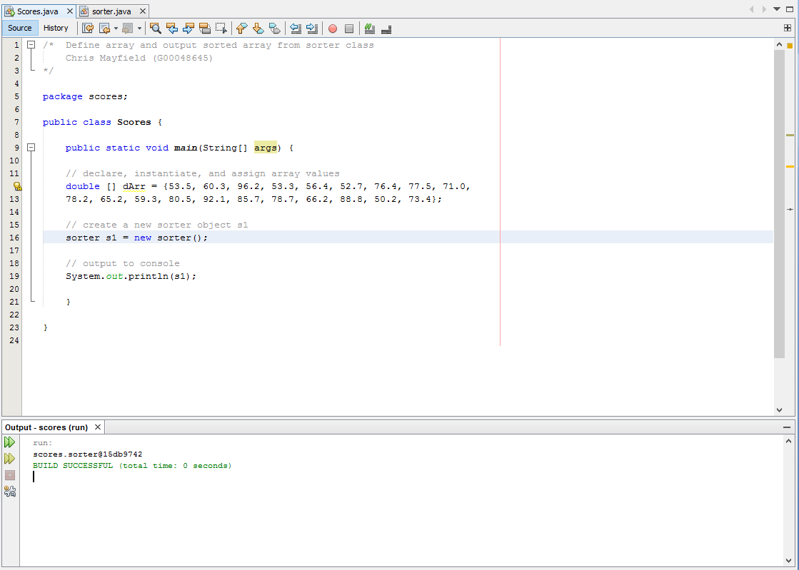

**Sorter (selection sort class)**

/* sorter class

Chris Mayfield

*/

package scores;

public class sorter {

public static void selectionSort (double [] dArr){

// initialize variables

int i = 0, j = 0, smallest = 0;

double temp = 0.0;

// loop for sorting

for (i = 0; i < dArr.length - 1; i++)

{

smallest = i;

for (j = 1; j < dArr.length - 1; j++)

{

if (dArr[j] < dArr[smallest])

smallest = j;

}

temp = dArr[smallest];

dArr[smallest] = dArr[i];

dArr[i] = temp;

}

}

}

